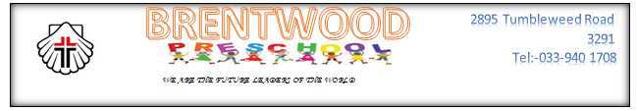

2022 BRENTWOOD PRE-SCHOOL PROGRAM

January 2022
15 | Saturday | Leadership Meeting
17 | Monday | Support staff and Academic staff report for duty and registration continues
18 | Tuesday | Academic planning meeting
19 | Wednesday | School opens for children
 | February 2022
02 | Wednesday | World Wetlands day
19 | Saturday | A.G.M Brentwood pre-school
14 | Monday | Valentine’s day & Civvies Day
 | March 2022
02 | Wednesday | Ash Wednesday
03 | Thursday | World Wildlife day
21 | Monday | Public holiday
23 | Wednesday | World Meteorological day
25 | Friday | Closing day for Term 1
 | April 2022
05 | Tuesday | Opening day for Term 2
10 | Sunday | Palm Sunday
14 | Thursday | Holy Thursday
15 | Friday | Good Friday - (Public holiday)
17 | Sunday | Easter Sunday
18 | Monday | Family day - (Public holiday)
22 | Friday | Earth day
27 | Wednesday | Freedom day - (Public holiday)
 | May 2022
01 | Sunday | Workers day
02 | Monday | Public holiday
08 | Sunday | Mother’s day
22 | Sunday | International Biodiversity day
26 | Thursday | Ascension day
 | June 2022
05 | Sunday | Pentecost/Whit Sunday & World Environment day
09 | Thursday | Father’s day
16 | Thursday | Youth day – (Public holiday)
17 | Friday | Special school holiday
24 | Friday | Closing day for Term 2
 | July 2022
18 | Monday | Nelson Mandela day
19 | Tuesday | Opening day for Term 3
31 | Sunday | World Ranger day
 | August 2022
08 | Monday | Special school holiday
09 | Tuesday | National Women’s day – (Public holiday)
12 | Friday | Civvies day to celebrate Women’s day
 | September 2022
15 | Thursday | International Coastal Clean-up day
16 | Friday | World Ozone day
22 | Thursday | World Rhino day
24 | Saturday | Heritage day
27 | Tuesday | Civvies day to celebrate Heritage day
30 | Friday | Closing day for Term 3
 | October 2022
03 | Monday | World Habitat day
11 | Tuesday | Opening day for Term 4
 | November 2022
21 | Monday | World Fisheries day
26 | Saturday | Graduation day for grade Rs
30 | Wednesday | Class parties for Grade RR & RRR
 | December 2022
02 | Friday | Durban Trip – (Beach)
14 | Wednesday | Closing day for Term 4 (2022)
16 | Friday | Day of Reconciliation

N.B. – All public holidays highlighted in RED, NO SCHOOLING

